Topic: Induction
Level: Entry level 1 - 3 / Scottish Access 2 – National 4 / CEFR A1 - B1
Time: 140 minutes plus extensions. You may wish to split the lesson over 2 or more sessions

Aim
- To help prisoners become more familiar with the vocabulary involved in induction.

Objectives
Some/all learners will be able to:
- use 10 essential prison words
- read a basic timetable of activities
- understand a simple map of the prison and identify key areas in the prison
- ask for and understand directions to key places around the prison.
- use the canteen sheet

Introduction
This lesson is designed to help learners to understand the process of induction. It covers commonly heard terms around the prison and provides practice in asking for directions to various places around the prison so a new arrival will understand facilities available. There are also activities to develop and practise wh questions to enable prisoners to become more independent. The lesson concludes with a brief look at the canteen sheet, which is covered in more detail in other Offender Learning resources (self access pack Eating in prison; teacher’s pack Food in prison, Unit 2 Rules and requests; teacher’s pack Buying things in prison, Unit 1 Catalogue).

Preparation
You will need:
- Resource 1: flashcards, 1 to display to learners
- Resource 2: definitions, 1 set cut up per pair of learners (laminated if possible) and 1 copy per learner (if required)
- Resource 3:gap-fill, 1 per pair of learners and 1 copy per learner (if required)
- Resource 4: images, 1 to display to learners and 1 copy per learner (if required)
- Resource 5:directions, 1 to display to learners
- Resource 6: 1 copy with drawings prison buildings and routes added and 1 set of cut out squares for each pair of learners
- Resource 7: induction timetable, 1 per pair of learners
- Resource 8: daily timetable, extension activity - 1 per pair of learners
- Resource 9: questions, 1 per pair of learners
- Resource 10: questions, extension activity - 1 per learner
- Resource 11: canteen items,, 1 to display to learners
- Resource 12: canteen sheet , 1 per learner
- Resource 13: extension activity - 1 per pair of learners

Procedure
Warmer (10 minutes)
- Show the pictures from resource 1 and write the word prison in the middle of the board. The 2 pictures of the wing and a cell.
- Elicit all they know about prison and associated vocabulary.

Activity 1: Essential vocabulary (15 minutes)
- Hand out one set of resource 2 word cards to each pair of learners. Explain that these are prison words that they might hear.
- Show the words on the board, point to and read one of the words out and ask the class to repeat and hold up the word from their pack. Check pronunciation / syllable stress.
- Hand out definition cards. Learners work in pairs to match the word to the definition. Allow them to use dictionaries.

Activity 2: Checking vocabulary (15 minutes)
- Display resource 3 on the board and elicit the first word: healthcare.
- Put learners with those of the same level, hand out the resource and ask learners to write the word in the spaces.
- Learners read their sentences out to the class. This is an opportunity for you to listen to pronunciation.
- Then ask learners to spread the word cards face down on the desk. Learners work in pairs with each learner picking up a card and trying to remember the definition.
Differentiation / extension
- Lower-level learners: choose the word card and definitions from the top half of the gap fill activity. Ask learners to do only the top half of the gap-fill today: they can do the next half another session.
- Lower level-learners: mix cards (word cards + definition) and place them face down on the desk, then get learners to do pelmanism (turn over two cards to match pairs: cards to definitions).
- Higher level learners can create sentences using the words they have picked up.

Activity 3: Additional vocabulary (15 minutes)
- Display resource 4 and elicit some of the words.
- Group learners with similar levels, hand out resource 4 to pairs and ask them to write the words next to the picture. Words: gym; healthcare; library; kitchen; laundry; landing; gardens.
- Feedback to board for correct spellings and drill all the words.
Differentiation
- Lower-level learners: once the higher level learners are writing, work with the group to introduce and drill the vocab pointing to the relevant picture.
- Write vocab on a small white board, ask learners to say the word and point to the picture.
- Finally learners can write the word from the whiteboard next to the pictures.

Activity 4: Introduce prepositions of place (15 minutes)
- Elicit from learners the names of the various buildings within your prison. These may relate to some of the pictures.
- Demonstrate the meanings of next to, opposite, near, behind with the use of classroom objects; pens, books, etc. for example say ‘The pen is next to the book.’
- Ask the class ‘Where’s the gym?’ and ensure learners use target language when replying i.e. ‘It’s next to the.....opposite the....’
- On the board draw a plan of your classroom, marking on the cupboards, tables doors, etc. as simple squares. Make sure you use words they know as there is already a lot of new vocabulary in this lesson.
- Ask ‘Where’s the cupboard?’ and demonstrate from the drawing that it’s next to/ near/ opposite the .......
- Hand out blank sheets of paper - coloured looks nice. Write up the names of key buildings that are present at your prison
- Ask learners to draw a plan of the prison, marking on the paths and key buildings
- Learners work in pairs and ask ‘Where is the ….?’
- Write the prepositions on the board and drill them.
Differentiation/ extension
- Discuss where place actually are as learners may have marked buildings in different places. You can then model ‘The gym isn’t next to the dining hall, it’s opposite the dining hall.’
- Learners write sentences in workbooks to practise spellings.
Activity 5: Giving directions (20 minutes)
- Before the lesson, prepare resource 6 draw some rough plans of sections with names of the building / places in the prison that they use. Also mark paths / main routes.
- Display resource 5 or replicate the drawings on the board.
- On the board write, go straight, turn right, turn left, it’s on the right/left. Ask learners to match the phrases with the pictures. They can then copy these in their notebooks.
- Display resource 6 so learners can see then ask learners, ‘How can I get to the gym?’ As they tell you, move an object along the route.
- Go round the class, asking learners how to get to various places and move the object as they say.
- Hand out a set of squares for learners to draw their own map.
- Learners then work in pairs with one learner asking, ‘How do I get to the ....’ The second learner then has to use the target language explaining the route, whilst the first learner traces the route.
- Feedback and check by asking learners to start in one place and read out directions to one place e.g. the dining hall. As you read directions learners follow on their own maps and establish where you are sending them.

Differentiation Extension:
- Higher level learners: write simple directions to 2 or 3 places e.g. go straight, turn right/ left.
- Learners can use more complicated structures e.g. go past the......, go through the gate, go round the ......go to the end of the path.

Activity 6: Reading the induction timetable (20 minutes)
- Display resource 7 to the learners and elicit what it is and what it’s for.
- Elicit relevant Wh question words What/When e.g. ‘What time is lunch on Tuesday? ‘What time are visits on Saturday?’
- With learner working with similar levels, hand out one copy of resource 9 folded after questions 5 for each pair of low-level learners.
Differentiation/ extension
- Higher level learners: give them unfolded copy to do questions 5 to 8
- If you think it would be useful, use resource 8 (daily timetable) and resource 10 and ask them to answer the comprehension questions.
- Ask learners to write their own questions and work in pairs to ask and answer e.g. What are you doing on ....? When is lock up?
- If possible, obtain your own prison’s induction timetable and ask learners to write and answer similar questions.
- Use a blank timetable and elicit learners’ real daily timetable for week days and weekends. Learners can then write their own timetable.
Activity 7: Reading the Canteen Sheet (20 minutes)
- Elicit how you buy things in prison.
- Show resource 11 and ask learners to identify the products. Drill the words point to the picture then write the vocabulary on the board.
- Make sure the vocabulary is not visible. Put the learners into teams and play hangman type game (you could use a smiley face instead of the hanging man): points going to teacher if they get the letter wrong. Tell learners you are thinking of one of the objects from resource 11 and indicate the number of letters by dashes on the board. Ask teams in turn to suggest letters.
- Display Resource 12 (canteen sheets) and ask what it is.
- elicit what Qty and how many means and demonstrate how to fill it in with an example.
- Elicit questions you could ask to fill it in for a partner e.g. ‘Do you want any phone credit or stamps? (yes) What do you want? (1st class stamps) How many? (2)
- Hand out resource 12 and learners to complete with the items their partner requires.
- Learners then give the canteen sheet to their partner to check it is correct.
- Put learners with a different partner and get them to ask each other what they are going to buy. Elicit questions e.g. ‘What are you going to buy?’ and ‘How many?’

Differentiation/ extension
- Quick finishers can add other items and suggest prices. They could also add up the cost of what they have ordered.
- You could also introduce many for countable nouns.
Cooler (10 minutes)
- Use hangman game in 2 teams or small groups to revise relevant vocab from today’s session.
- Ask learners to describe how to get back to the wing from where they are now and what they will order this week from the canteen sheet.
Extension activities
- Additional vocab activity (resource 13) can be used during this session if learners already know much of the vocabulary used in this lesson.
- Use during a further session on this topic.
- Use resource 2 as revision at the beginning of the next session.
- Learners could write some advice to a new prisoner using some of the information/ vocabulary covered in this/ these session(s).
Answers
Resource 3
1) healthcare 2) roll check 3) VO or visiting order 4) Listener 5) movement
6) association 7) lock up 8) activities 9) IEP

Resource 9
1) Tuesday 2) Tuesday 3)10.-10.30 4) 13.30 5) see the nurse
6) about forms 7) Wednesday 8) complete English and maths assessments

Resource 10
1) 8.30 2) 18.45 3) Saturday 4) 8.30 5) lunch 6) collect evening meal.

Resource 1
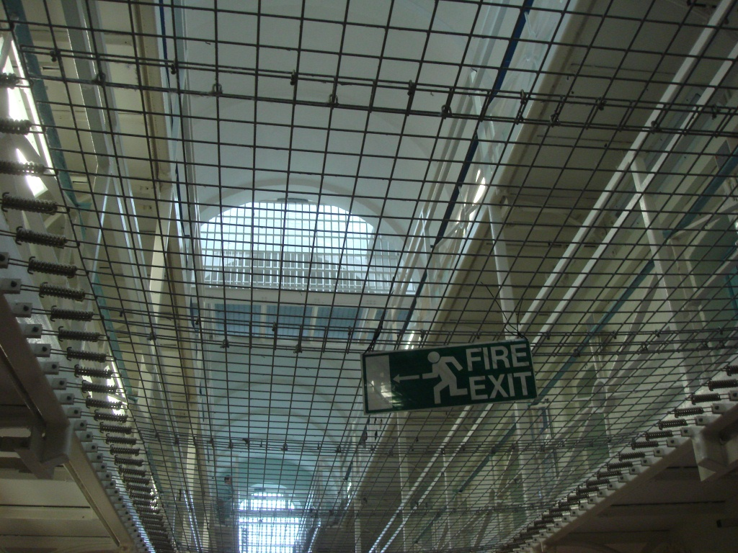
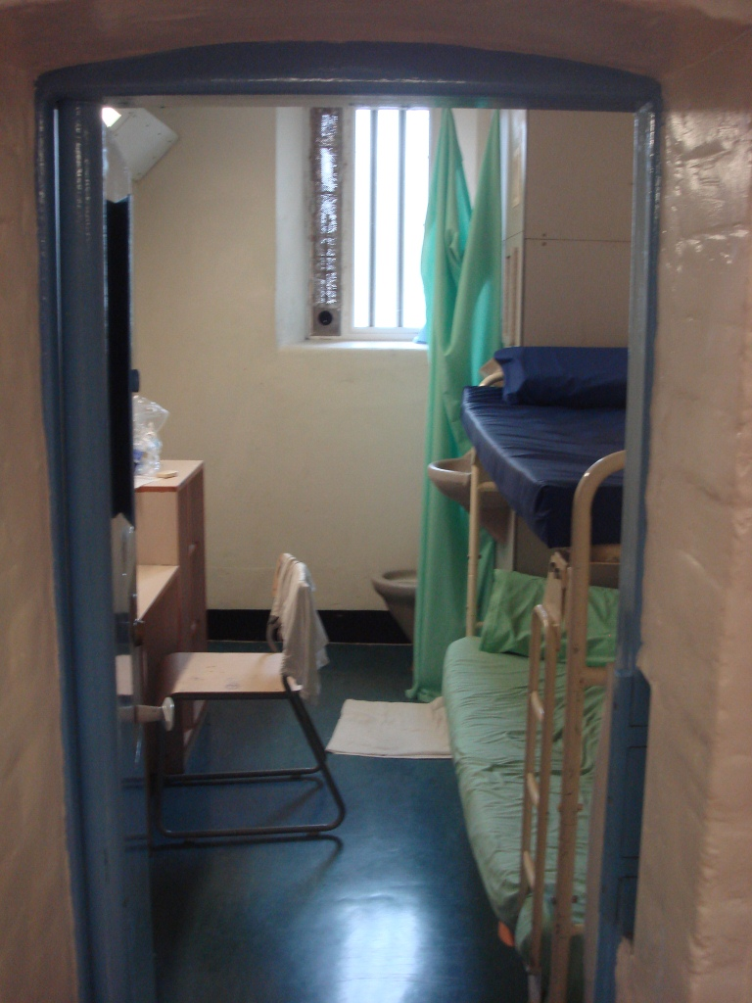
Resource 2 Definitions
free flow | you can move around to go to work or lunch or dinner
listener | a prisoner you can talk to
association | free time to talk to friends
roll check | everyone is counted
lock up | you are behind your door
activities | things you do in the day
healthcare | go here if you are ill visiting order
VO | Visiting Order – a form so family/ friends can visit
IEP | Incentives and Earned Privileges – a bad/ good mark on your record

Resource 3

roll check; free flow; listener; healthcare; visiting order

Put one of the words/phrases above into the following sentences.
- I don’t feel well. I must visit …………………………………
- When we go to our rooms at lunchtime and in the evening, they count us for ……………………………………….
- My brother wants to visit me. I must fill in a ……………………………
- If I feel sad or unhappy, I can talk to a …………………………………
- To go from one place to another is called ………………………………

lock up; association; activities; IEP

- Time to talk to people on the wing is called ……………………………
- …………………………. is when we are in our rooms at night until the morning.
- The things we can do in a day are called ………………………………
- If you do something well, or you do something bad you can get an ………………

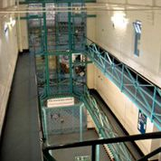
Resource 4 Name the place
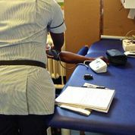
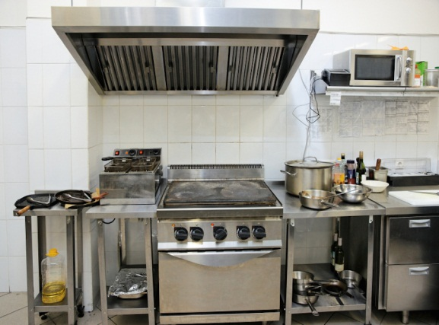

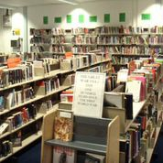




Resource 5 Directions

1 2

3

4 5

Resource 6

 | 8.30-9.00 | 9.00-9.30 | 9.30-10.00 | 10.00-10.30 | 10.30-12.00 |  | 13.30-15.00 | 15.00-15.45 | 15.45-16.30
Tuesday | Welcome to HMP  Interviews with induction officers |  |  | Meet your personal officer | Health and Safety talk | LUNCH | Tour of the prison | Meet the governor | Visit to the gym
Wednesday | Welcome to healthcare  Interviews with nurse |  |  | Education induction  Complete English and maths assessments |  | LUNCH | Work and  Activities  talk | Meet your wing officers  Learn about forms. | Question and answer  session

Resource 7: Induction Timetable

 | 8.30 | 8.30-12.00 | 12.15 | 12.30-13.30 | 13.45-16.30 | 16.45-17.45 | 17.45-18.45 | 18.45-19.45 | 19.45
Tuesday | go to work | at work/ activities | lock up and roll check | lunch | go to work /activities | lock up and roll check | dinner | association | lock up and roll check
Saturday | go to work if you work in kitchens | association | lock up and roll check | lunch | visits | collect evening meal | lock up and roll check
Resource 8: Daily Timetable
Resource 9
Use the Induction timetable to answer these questions

- What day can you meet the governor?
- What day is the tour of the prison?
- What time do you meet your personal officer?
- What time does lunch finish?
……………………………………………………………..
- What do you do when you visit healthcare?
- What will the wing officers teach you?
- What day is the question and answer session?
- What do you do at the education induction?

Resource 10

Use the daily timetable to answer these questions

- What time do you go to work?
- What time is association on Tuesday?
- What day are visits?
- What time is association on Saturday?
- What do you do at 12.30 on Tuesday and Saturday?
- What do you do at 16.45 on Saturday?



Resource 11 Canteen items

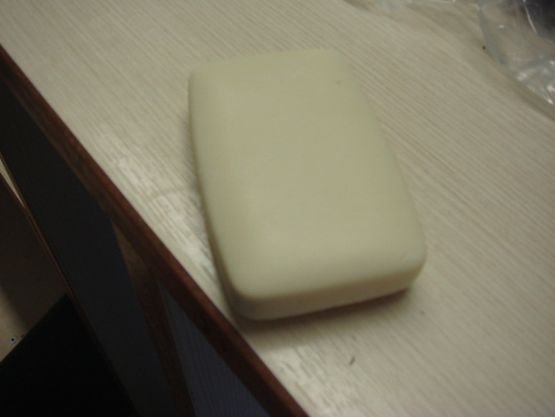
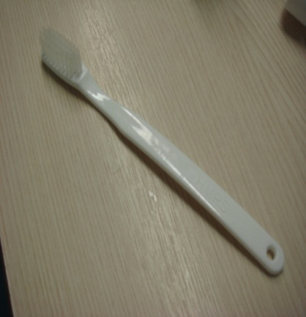

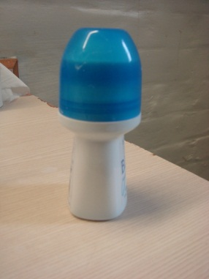








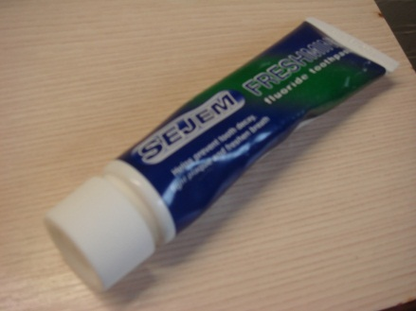
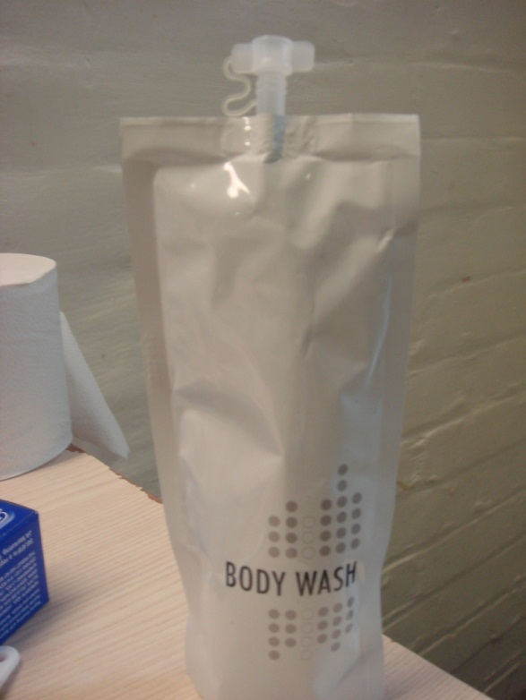





Resource 12: Canteen Sheet

Phone and Stamps
Price | Item |  | Qty
£1.00 | phone Credit
£0.62 | 1st class stamp
£0.53 | 2nd class stamp
Toiletries and Health

£1.15 | toothbrush
£2.03 | Aquafresh toothpaste
£2.99 | Colgate  toothpaste
£1.00 | deodorant
£1.25 | shampoo
£2.00 | body wash
Sweets and Snacks

£1.00 | a bar of chocolate
£0.50 | Polo original mints
£0.50 | Mars bar
£0.50 | Plain crisps
£0.50 | salt & vinegar crisps

Resource 13
cell | your room
wing | the block where you live
governor | the person in charge of the prison
induction | when you arrive – what you learn about prison life
app | a form you fill in if you want something
dentist | a person who looks after your teeth
reception | the place where you go when you arrive
canteen sheet | a list of things you can buy
gym | a place where you exercise

